VowelQuest
The speech synthesis tool VowelQuest is a piece of software for phonetic/phonological research into vowel systems.
VowelQuest allows the user to pinpoint vowels in the acoustic space, by identifying what constitutes aurally the best fit to each of the vowels in their language. The tool provides as output the list of formant frequencies that correspond to these perceptually identified vowels.
The user ‘gropes around’ by clicking in the F1-F2 plane, and hears the corresponding sound. The third formant, F3, is modified independently. In order to facilitate the search in the F1-F2 acoustic plane, the user is able to visualize both the latest point that they clicked (current values, corresponding to the sound that is played) and the previous point, so as to be able to track the difference between successive choices.
This software is based on program of Pr. René Carré, named « Best Vowel », written in Borland C Builder for specific experiments in speech production research. The program was written anew in the Visual C language, with René Carré’s permission. New features have been added to make the tool more readily usable by novice users.
Highlights:
- A tool to become familiar with formant synthesis
Synthesizing speech from formant values is a good way to approach the Acoustic Theory of Speech Production (Fant 1960), which is the backbone of modern approaches to acoustic phonetics (e.g. Stevens 1998).
- Friendly interface
The present tool retains the advanced functions of R. Carré’s original script. But the interface was devised so that the tool can be used by students without a prior command of phonetics software. Beginners should find it easy to get started and use this software for perceptual tests.
- Unicode encoding for vowel symbols
to ensure correct display of International Phonetic Alphabet symbols, as well as of orthographic representations in any of the world’s writing systems.
- Manipulation of three formants
In many vowel systems, the third formant is an important dimension of the acoustic definition of vowels. For example, the contrast between /i/ and /y/ is typically a matter of F3 target, and rhotic vowels (as in American English bird or Mandarin –er 儿) are characterized by an especially low F3, sometimes below 2,000 Hz.

Installation
VowelQuest program can be started directly from execute file in the unzip folder.

User guide
Step 1: Data preparation
First of all, user need to prepare (or use existing) list of vowels to test. Then they can demand other people to pinpoint vowels in the acoustic space, by identifying what constitutes aurally the best fit to each of the vowels in the list.
The format of the file containing list of vowels is described in the figure below.
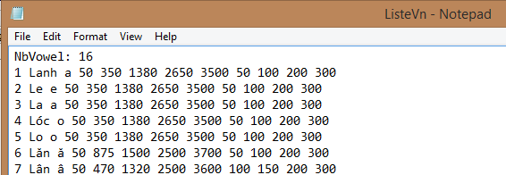
+ First line indicates number of vowels to test : “NbVowel:#” with # is the number of vowels.
+ Following lines: Each line contains information for each test, space-delimited data.
“ID Example Testvowel Vowelduration F1 F2 F3 F4 B1 B2 B3 B4”
For example, Line no 10, we do a test for vowel “e”, for example in the word “Le”, with the vowel duration is 120 millisecond, formant values F1=350, F2=1380, F3=2650, F4=3500, and formant bandwidths B1=50, B2=100, B3=200, B4=300. The Example and the Testvowel can be written using UTF-8 character in orthography or IPA.
Step 2: To start testing, select the text file containing list of vowels. Then click Start button.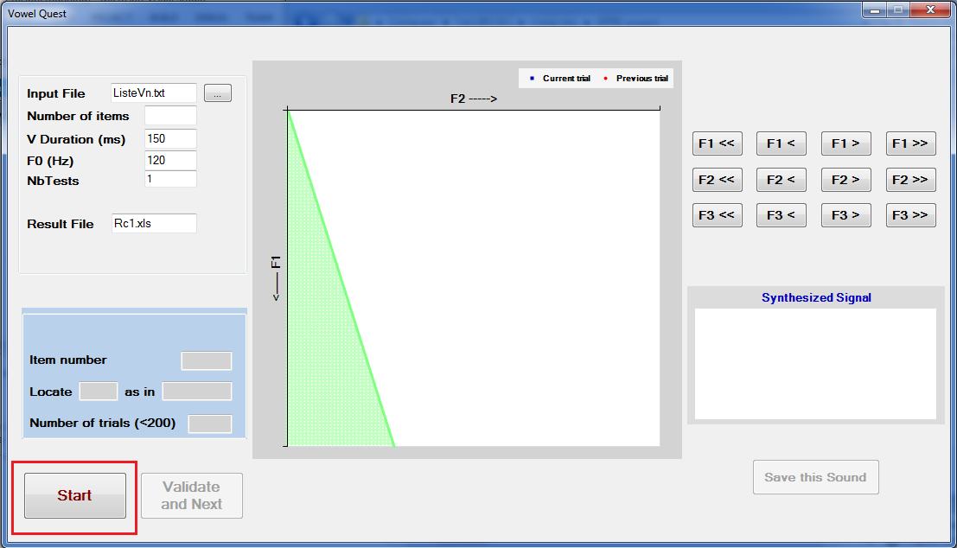
Step 3 : For each vowels, you will see the question, for exemple “Locate “e” as in “Le” ?”. Then click left mouse inside the F1, F2 plane (white area) to find suitable value for this vowel.
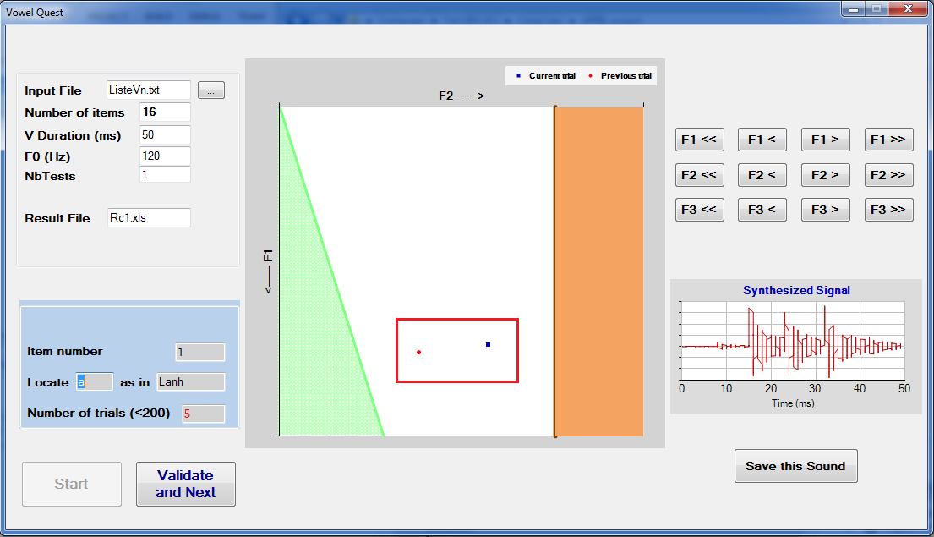
You can use also button group on the right to modify F1, F2, F3 values of this vowel step by step.
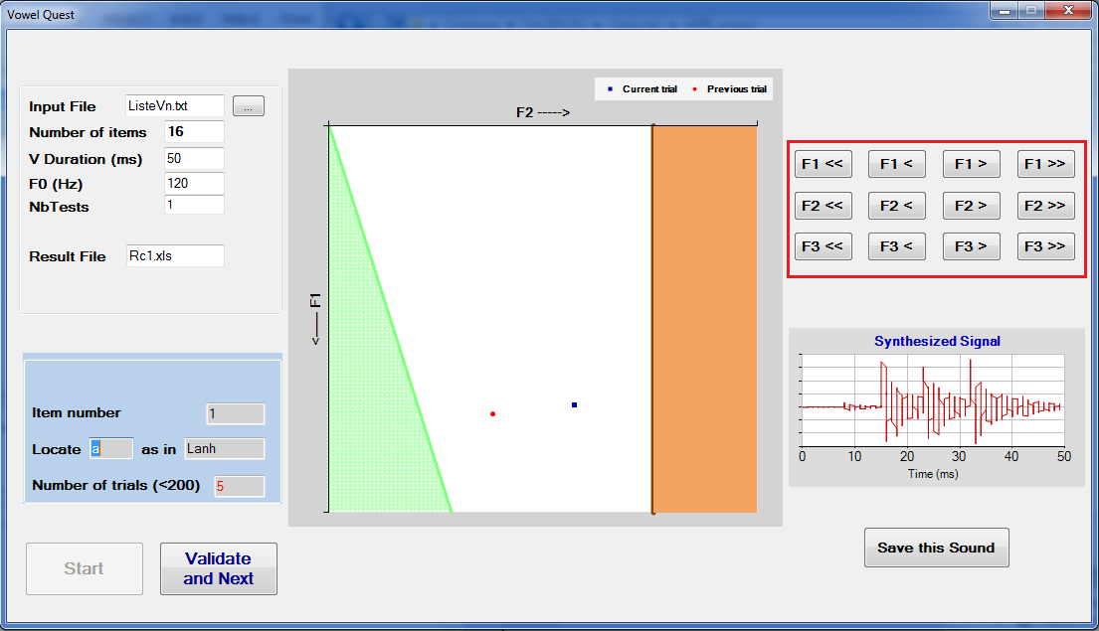
For tracing, in the F1/F2 plan, there are always two color points (red and blue). The red point is the previous trial and the blue point is the current trial.
If you want to save this sound, please use “Save this Sound” button.
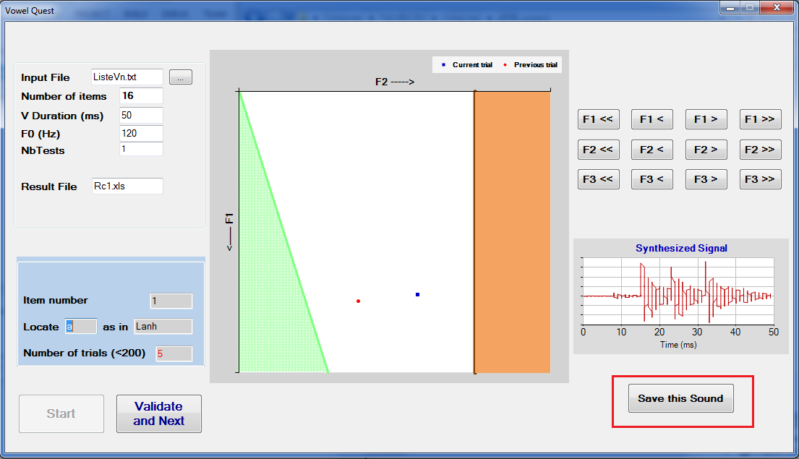
Step 4 : When you finish finding the best value for the current vowel, click “Validate and Next” button to continue testing the next vowel.
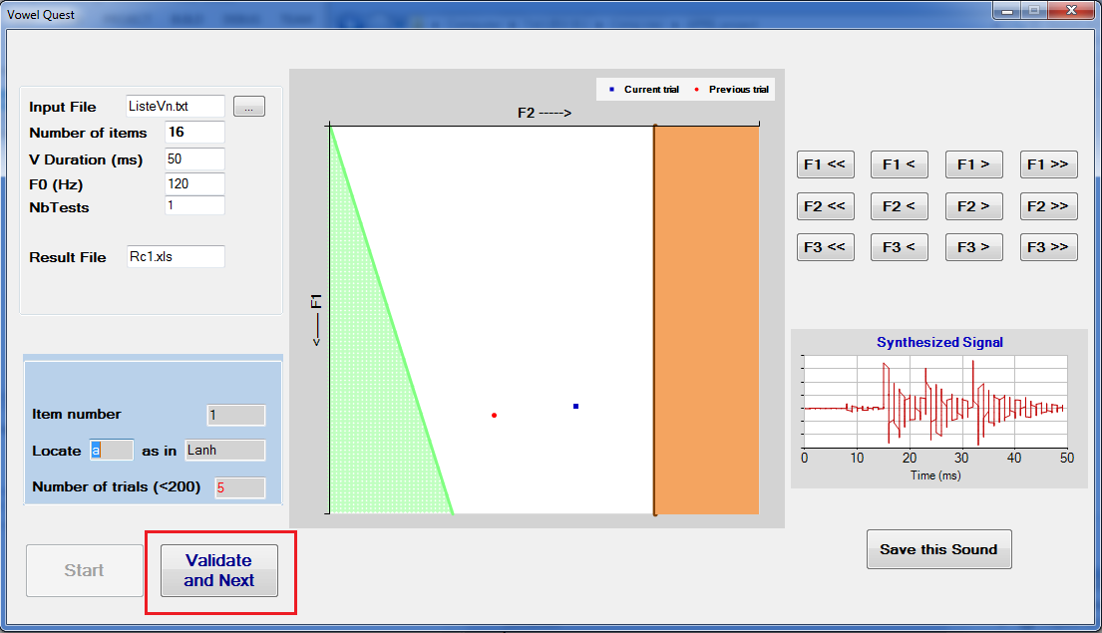
Step 5 : When finishing all vowels in the list of vowel, all information done by subject will be recorded in the output file (the file name indicated in Result file text box).
The output file contains two parts, one for saving all user’s trials for each test, and one for resume.
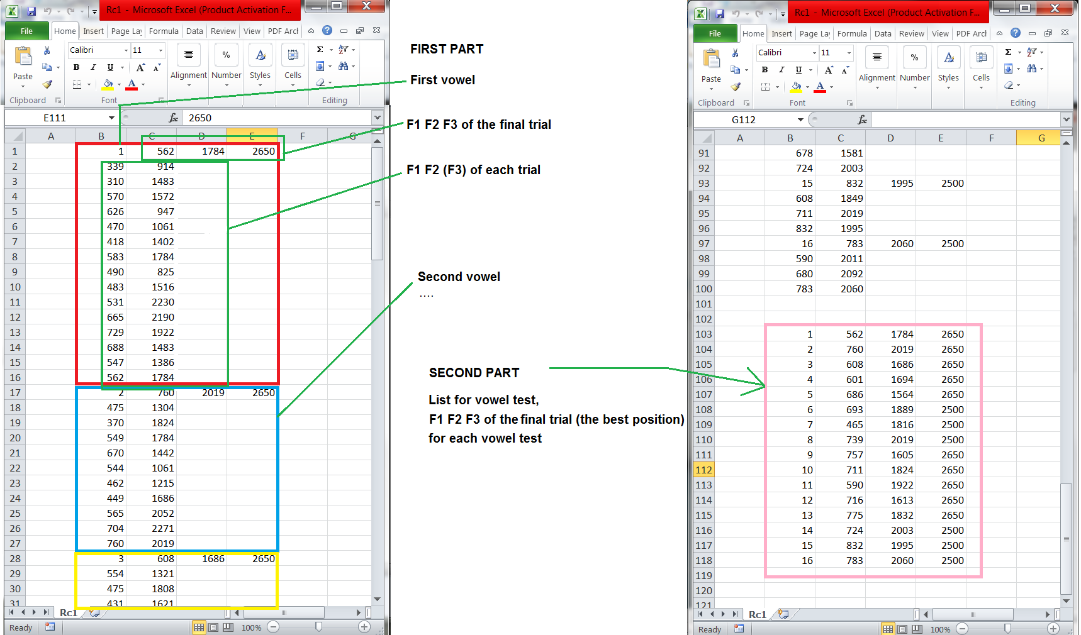
The first part contains information for three formant values F1, F2, F3 for each trial of each vowel test. The second part contains information for the best trial of each vowel test.

Contact
Speech Communication department , MICA International Research Institute.
Post address: Room 1004 - Building B1 - Hanoi university of Science and Technology – No1 Dai Co Viet street – Hai Ba Trung – Hanoi - Vietnam
Email :
+ Nguyen Viet Son (Viet-Son.Nguyen) at mica point edu point vn
+ Alexis Michaud (Alexis.Michaud)
+ Nguyen Tien Thanh (Tien-Thanh.Nguyen)
+ Do Thi Ngoc Diep (Ngoc-Diep.Do)

http://ren.carre.pagesperso-orange.fr/index.htm

